MONGODB ASSIGNMENT B
- Create a database named university and a collection named students. Insert multiple student documents with fields: name, age, department, and grades.
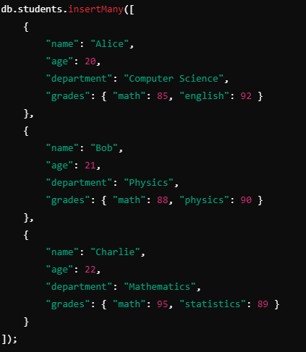
1A-use university
1B-db.createCollection("students")
1C-db.students.insertMany([{name:'Alice', age:20,department:'Computer Science', grades:{math:85,english:92}}, {name:'Bob', age:21, department:'Physics',grades:{math:88,physics:90}}, {name:'Charlie', age:22,department:'Mathematics', grades:{math:95,statistics:89}}])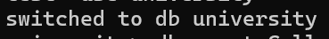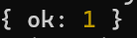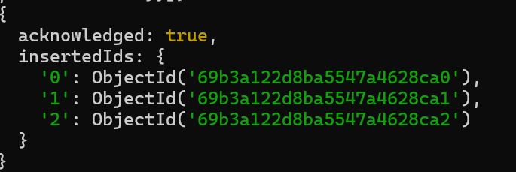
- Write a query to display all students who are in the Computer Science department.
db.students.find({ department: "Computer Science" })
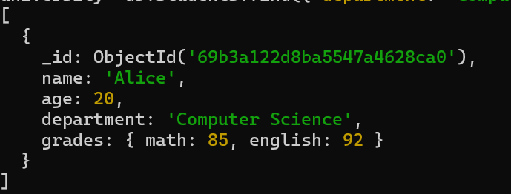
- Write a query to update the grades of a student named Alice by adding a new subject programming with a grade of 93.
db.students.updateOne({ name: "Alice" },
{ $set: { "grades.programming": 93 } })
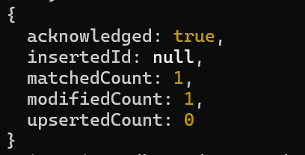

- Write a query to increment the age of all students by 1.
db.students.updateMany( {}, { $inc: { age: 1 }})
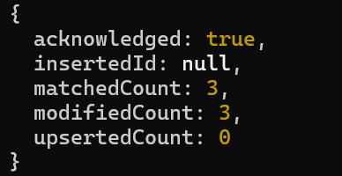

- Write a query to delete all students who are 23 years old.
db.students.deleteMany( { age: 23 })

- Write a query to create an index on the name field of the students collection.
Topic not covered

- Write an aggregation query to group students by their department and calculate the average age in each department.
db.students.aggregate([
{ $group: { _id: "$department", avgAge: { $avg: "$age" } }}])
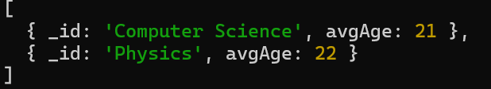

- Write a query to find all students who have scored more than 90 in any subject.
db.students.find({ $or: [ { "grades.math": { $gt: 90 } }, { "grades.english": { $gt: 90 } }, { "grades.physics": { $gt: 90 } }, { "grades.statistics": { $gt: 90 } } ]})

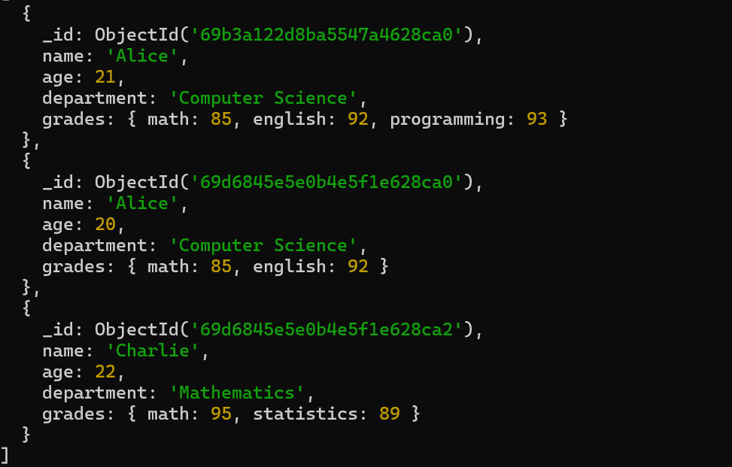

- Write a query to add a new field graduated set to false for all students who are in the Mathematics department.
db.students.updateMany({ department: "Mathematics" }, { $set: { graduated: false } })
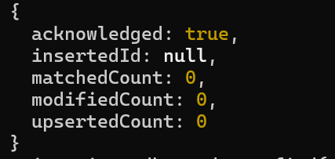
10.How can you retrieve only the name and department fields for all students, excluding the _id field?
db.students.find({},{ name: 1, department: 1, _id: 0 })
